**Programming Paradigms Laboratory**

**B.Tech.**



**Name : Tanishq Porwar**

**Roll Number : 18ETCS002131**

**Department : Computer Science and Engineering**

**Faculty of Engineering & Technology**

**Ramaiah University of Applied Sciences**

|  |  |
| --- | --- |
| Faculty | Engineering & Technology |
| Programme | B. Tech. in Computer Science and Engineering |
| Year/Semester | 2nd Year / 4th Semester |
| Name of the Laboratory | Programming Paradigms Laboratory |
| Laboratory Code | 19CSL217A |

# Laboratory 4

Title of the Laboratory Exercise: Two dimensional arrays

1. Questions
2. Develop a GradeBookTest class with an instance variables **string course name** and **2D array(5*3) of marks** of several student, each row indicates students three term test marks and each column indicates grades of all students, define a constructor to initialize instance variables and display average marks of each student, lowest grade and highest grade.
3. Develop a java program to read a square matrix and print its upper and lower triangle of a square matrix.
4. Calculations/Computations/Algorithms

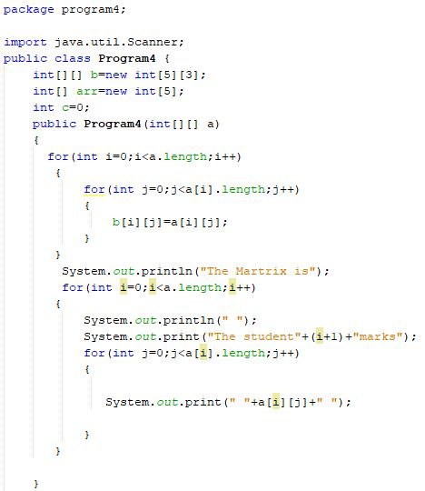

Fig 1.1

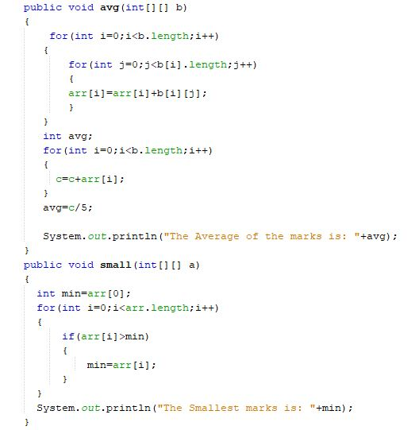

Fig 1.2

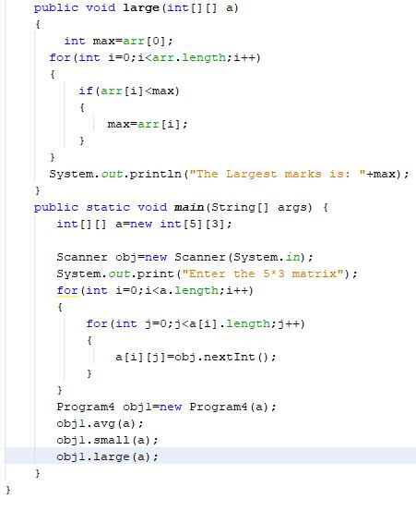

Fig 1.3, 1.2, 1.1 Represents the java program of GradeBookTest class with an instance variables **string course name** and **2D array(5*3) of marks** of several student

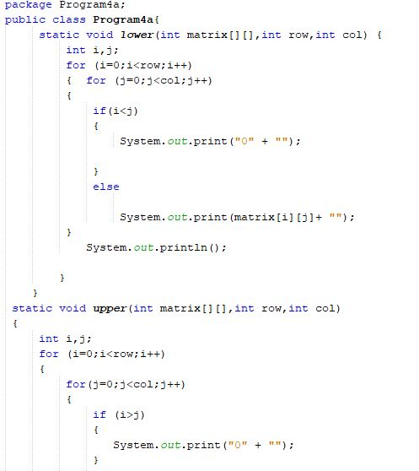

Fig 2.1

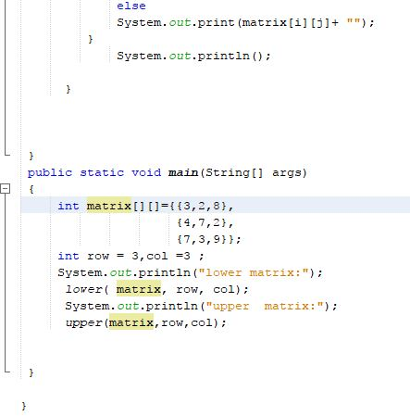

Fig 2.2, 2.1 represents the java program to read a square matrix and print its upper and lower triangle of a square matrix.

1. Presentation of Results

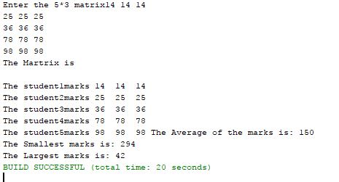

Fig 1.4 represents the output of the GradeBookTest class with an instance variables **string course name** and **2D array(5*3) of marks** of several student

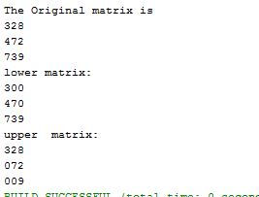

Fig 2.3 represents the output of the java program to read a square matrix and print its upper and lower triangle of a square matrix.

1. Conclusions

We have learned how to use 2-dimensional array in java and how to use it to do several operations like retrieving the upper and lower triangle of a square matrix, and like many other things that are same as the single dimensional array.

1. Limitations of Experiments and Results

We cannot do any operation in array without importing the array packages and their methods and the 2 dimensional array cannot be accessed by initializing the array by [][] in the declaration part.